**Overview of the Source Code and Data Backup**

**Source Code** **2**

a. Application_for_System_Prototype 2

Process management dashboard 2

Project KPI evidence dashboard 2

Project factors setting interface 3

Risk calculator 4

b. Scripts_KIE-DROOLS 5

c. Scripts_OrientDB 5

e. Scripts_NodeJS_MongoDB 5

**Data Backup** **6**

a. Data_backup from OrientDB 6

b. BPMN_Diagram_Activiti 6

# Source Code

## a. Application_for_System_Prototype

### Process management dashboard

### Project KPI evidence dashboard

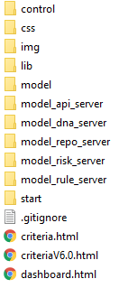

./dashboard.html

* The interface of Project Management Dashboard

./criterial.html and ./criteriaV6.0.html

* The interface of KPI evidence dashboard

./control

* Holds the business logic for loading and event handling those interfaces

./model

* Handles communication with Activiti (BPMN engine), which controls the workflow of tasks in a project

./model_api_server

* Handles communication with MongoDB/NodeJS server, which is stores internal data of the system (e.g. project id, factors settings, etc.)

./model_dna_server

* Handles communication with OrientDB(Data Normalization Architecture) server, which stores project data

./model_repo_server

* Handles communication with code analysis result. Currently not used

./model_risk_server

* Handles communication with the risk prediction engine API

./model_rule_server

* Handles communication with the KIE-DROOLS (Rule engine), which we used in the early stage.

./start_page

* Contains the factor input interfaces of the system prototype. Will be introduced in the following section

./risk_calculator

* Contains the risk assessment interfaces of the system prototype. Will be introduced in the following section

./css ./lib ./img

* Are the stylesheets, UI libraries and image source of this prototype

### Project factors setting interface

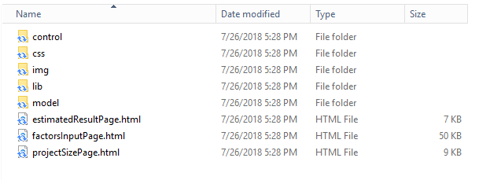

Control\:

* Contains scripts that implement the control flow of the pages, for example, estimationResultControl.ls, factorsInputControl.js, and projectSizeControl.js. Also the script to calculate project effort based on COCOMO: CocomoCalculator.js

CSS\

* The style files that control the appearance.

Img\:

* Include image resources.

Lib\:

* Includes the javascript libraries for displaying the pages.

Model\:

* Include the script to communicate with backend database.

estimatedResultPage.html:

* The page to display estimated result.

factorsInputPage.html:

* The starting page for setting project characteristics.

projectSizePage.html

* Set project size in termsl fo Source Lines of Code (SLOC)

### Risk calculator

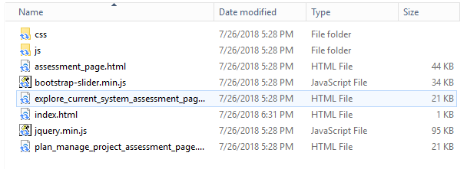

css/:

* holds the css style files for the web pages.

js/:

* holds the control flow for the web pages.

Assessment_page.html:

* includes the risk assessment questions and criteria for different phases and aspects.

Explore_current_system_assessment_page.html

* includes the risk assessment questions and criteria in terms of current system exploration phase.

Factors_input_page.html

* Includes the evaluations in terms of produce, platform, personnel, and process aspects for risk assessment and effort estimation.

Plan_manage_project_assessment_page.html

* includes the risk assessment questions and criteria for plan management.

## b. Scripts_KIE-DROOLS

./evidenceRule/src/main/java/demo

* Defines all the required objects used for posting a rule

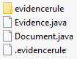

./evidenceRule/src/main/resources/demo/

* Defines a rule for evaluating if all evidence KPIs under Feasibility Phase are satisfied



## c. Scripts_OrientDB

There are 2 trigger functions and 10 KPI assessment functions. Please refer to the document under the source code file.

The scripts in OrientDB are also exported and included in "Data_backup" folder

## d. Scripts_NodeJS_MongoDB

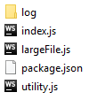

./index.js

* The launch file for running node server. Contains basic REST APIs for system prototype to access MongoDB

./largeFile.js

* Contains the REST API to upload evidence document

./utility.js

* Contains the utility functions

./package.json

* Contains the description of the node modules required for launching the node server

./log

* The place for logging

# Data Backup

## a. Data_backup from OrientDB



./Test.gz

* Contains all data and predefined functions in the Test database. Exported from the current OrientDB instance.

./QualityManagement.gz

* Contains all data and predefined functions in the QualityManagement database. Exported from the current OrientDB instance

## b. BPMN_Diagram_Activiti

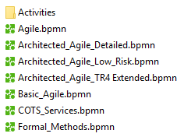

./*.bpmn

* Are used for describing the workflows for different processes. Those diagrams are at very high-level description. They were used in the early stages

./Activities/*.bpmn

* Contains all diagrams used for describing a set of single activities within a process workflow. They are used in the latest system prototype

